ABSTRACT

In today’s Modern world scarcity of water and energy has become a global issue. There are still a few places where we do not get electricity, especially in villages, where agriculture is the backbone of their livelihood. For flawless irrigation, they need an eminent amount of power to operate their pump and calculate how much water to use as some villages are still dry. An interface is also required to keep track of all these. Our project aims to address all the above-mentioned issues by developing a system that uses a dual-axis solar tracker to power the water supply, and implementation of different sensors to predict the need, level and usage of water on real real-time basis. A web application to keep an eye on all these things. It facilitates continuous monitoring of the system by giving SMS notifications to users at regular intervals. The dual-axis solar tracker present in the system provides the appropriate amount of energy to operate the water pump. The presence of moisture sensors, ultrasonic sensors and water flow sensors in the system helps to observe soil conditions, the level of water in the tank, water required at different times and weather conditions. All of this data is stored on a real-time basis in Google Firebase and reflected on our web interface which helps users to keep track of these things globally.

**Introduction**

With the rapid increase in the Indian population, the food production rate should be enough to meet all needs. In this scenario, we need some advanced tools and techniques for plant maintenance and irrigation purposes. For efficient control, we need sensor fusion and web-based control systems [1]. By integrating different technologies, the system addresses different challenges like resource utilization providing solutions for viable agriculture and effectively transforming the agricultural sector [2]. One can utilize IoT cloud platforms, and focus on real-time monitoring to optimize the use of water in farming. Farmers can efficiently manage irrigation by receiving alerts about watering status, soil conditions and many more [3]. Integrating sensors, and wireless technologies, the system can aim to optimize crop management, and resource utilization. One could revolutionize precision agriculture, offering a variable tool for farmers to enhance productivity and sustainability [4]. The overall efficiency of water pumps can be increased by powering them with the help of solar trackers. By incorporating sun tracking technology the rechargeable batteries connected with the water pump get charged and provide power to the pump. This minimizes the use of non-renewable sources of energy [5]. The hardware setup equipped with an efficient remote monitoring system enables users to globally access all data and results [6]. Whenever there is a change in soil conditions, water level etc., the sensors update the data in the system and trigger the water pump accordingly. The system connected with Google Firebase and website helps users to track all this data and results from any part of the world. An IoT-based smart irrigation system using sensor fusion, dual-axis solar tracker, Google Firebase and a website can efficiently monitor soil moisture conditions and ignite the water pump according to the moisture value, keeping track of water stored in the pump for irrigation purposes. The data fetched from sensors are stored in real-time in Google Firebase with the help of wi-fi connectivity of the NodeMcu microcontroller. The implementation of a dual-axis solar tracker provides renewable energy to the water pump for working. The website facilitates global access to all these data.

This paper proposes to develop a system using sensor fusion, dual axis trackers to reduce the usage of electricity, effectively manage plants, and track the amount of water present to water the plants. Remote access to all these things makes the process automated, minimizing labour from the field. The main focus of this paper is as follows: -

1. Develop a system using the sensor fusion method to monitor soil conditions and moisture levels.
2. Using a dual-axis solar tracker to power the water pump.
3. A real-time database to ensure that the data from sensors is fetched and stored in real-time for better understanding of planting conditions.
4. A website to remotely monitor all the procedures, data and results globally.

The paper is divided into various sections. In section 2 , we discuss past developments of such systems. Section 3 gives the concept and schematic diagram of our system. Section 4 details the system architecture, and implements a testing setup. Results and other data is discussed in section 5. The paper is concluded in section 6.

**A brief report of literature survey on related developments**

The paper by Rumy et al. gives an innovative approach for a disease detection system, the system promises remarkable potential in revolutionizing agricultural practices by enabling real-time monitoring [7]. Dual-axis solar trackers maximize energy capture and address the need for effective and efficient renewable energy sources. They are superior to fixed and single-axis trackers, contributing to significant improvements in efficiency [8]. Advancements in automated irrigation systems, emphasize the role of sensors, PLCs and different communication technologies. Different methodologies are integrated to estimate effective irrigation and provide robustness [9]. A wireless decision support system for optimized irrigation management, using low-cost sensors and neural network-based systems to reduce water wastage, improving water resource utilization by crops through an automated system [10]. A self-operating agricultural system using web technologies to optimize water usage and crop management. Remotely collection of data, facilitating real-time monitoring, and developing water-resource utilization. A user-friendly interface to remotely monitor and control irrigation processes [11]. Addressing the need for water conservation in agriculture by integrating different technologies. A central cloud data storage and machine learning algorithms for conserving water, improved the production of crops [12]. Systems using microcontrollers as a central system achieve robustness and flexibility. Wireless systems eliminate the need for wired connections and provide simplified installation and maintenance. Cloud monitoring facilitates monitoring and control of the system globally [13]. Integration of wireless sensor networks focuses on the uses of Zigbee technologies. This leads to an increase in feasibility and functionality in the real world [14]. By fusing different technologies, the efficiency of crop cultivation can be enhanced [15]. Joshi, A. Y.[16] tackles key issues of soil moisture management, improving the potentiality of crops, and providing real-time monitoring and control based on environmental conditions. Obaideen, K., Yousef,[17] offer an understanding of minimizing water usage, saving energy and developing crop yield productivity. Artificial Intelligence and machine learning algorithms improve decision-making processes and minimize risk. The use of IoT enhances water-saving irrigation practices, hardware practices and software processes are involved in effective irrigation [18]. A low-cost system comprising sensors, microcontrollers and different communication modules can be vital in modernizing cultivation practices. This improves water management, efficient monitoring of crops and other things in farming practices [19]. A broad system fusing sensors for observing environmental conditions and automating the entire process of irrigation, the effectiveness of the model through real-world analysis, reducing energy consumption, and developing crop productivity [20]. Sensor fusion to monitor soil and climate conditions, automating water usage and reducing wastage. Sustainable irrigation practices with reduced human efforts [21]. Integrating IoT technologies addresses challenges faced by farmers such as soil moisture and climate conditions. Wireless and data logging systems enable real-time monitoring of conditions [22]. A system tailored for middle-class farmers, offering cost-effective and efficient water managing techniques. Fusing sensors, microcontrollers, and cloud-based monitoring automates the system and addresses different challenges [23]. Sharma, and Navneet [24] address the challenge of water management in irrigation purposes, the system is automated based on the real-time moisture value of soil. This enhances water management and crop productivity. Pimpalkar, P., Pedsangi [25] use Arduino UNO and soil moisture sensors to manage water usage in irrigation processes, this cost-effective solution reduces water wastage and improves crop productivity, combination of hardware and software increases its efficiency in the real world. A cost-effective real-time system with GSM addresses the limitations of conventional irrigation processes. This helps to save water and energy, and precise calculation enhances productivity [26]. A unique approach to monitoring crops and disease prediction using different machine learning techniques and algorithms, real-time collection and analysis of data [27]. Smart and precise farming ensures sustainability by collecting data from various resources. Big data technologies detect and suggest different irrigation practices based on real-time and historical data [28]. Prediction of optimal crop choices based on environmental factors addresses solutions to inefficient utilization of resources and unpredictable weather conditions. The inclusion of various machine learning models and algorithms makes an effective and efficient system in the real world [29]. By fusing different sensors, getting real-time data, cloud storage and predictive analysis offers farmers to optimize crop production and irrigation techniques.

**Design of IoT-driven smart irrigation system using sensor fusion method and dual-axis solar tracker**

An Innovative design of IoT driven smart irrigation system is proposed in the given figure 1 and figure 2. This system is designed by integrating two sensors. These sensors are connected to the microcontroller, where the connection is established using wi-fi. The sensors fetch data on a real-time basis and store it in the real-time database of the Google Firebase. Users can get access to all these data using the web interface. The Google Firebase internally connects the web interface with the hardware system.

In the system, the ultrasonic sensor and soil moisture sensors are connected to the microcontroller. The soil moisture sensors check the soil conditions and send the data, according to which the pump is triggered and watering is done. The pump is powered using a dual-axis tracker that frees our system from using non-renewable energy sources. We emphasize using renewable sources of energy to minimize electricity use. A threshold value is set to measure the soil conditions, using this the pump is switched on/off. The ultrasonic sensors keep track of the amount of water present in the water tank from which the pump is using water for irrigation purposes. If the water present in the tank is low, Then the user gets a notification via the website so that it can be refilled again. Using Firebase and website the user can access soil conditions, watering status and tank level globally.

Power Supply

Relay

Moisture sensor

NodeMcu

Ultrasonic sensor

Dc Pump

Google Firebase

9v battery

Website

**Design**

Fig1: Schematic diagram of IoT based irrigation system

Dual-axis solar tracker

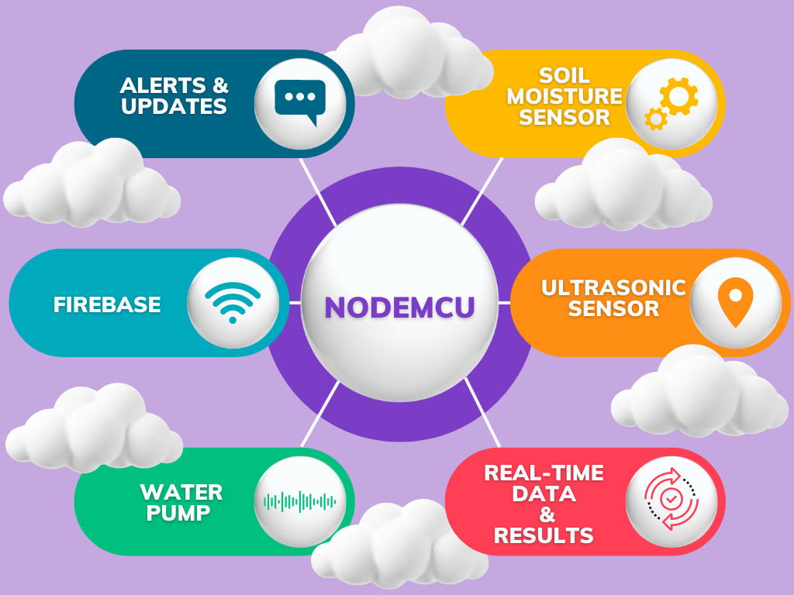

Fig2: Basic system design/architecture

To develop the system architecture of IoT driven smart irrigation system using the sensor fusion method and dual-axis solar tracker using Firebase and website, the following components are used according to the below fig3:

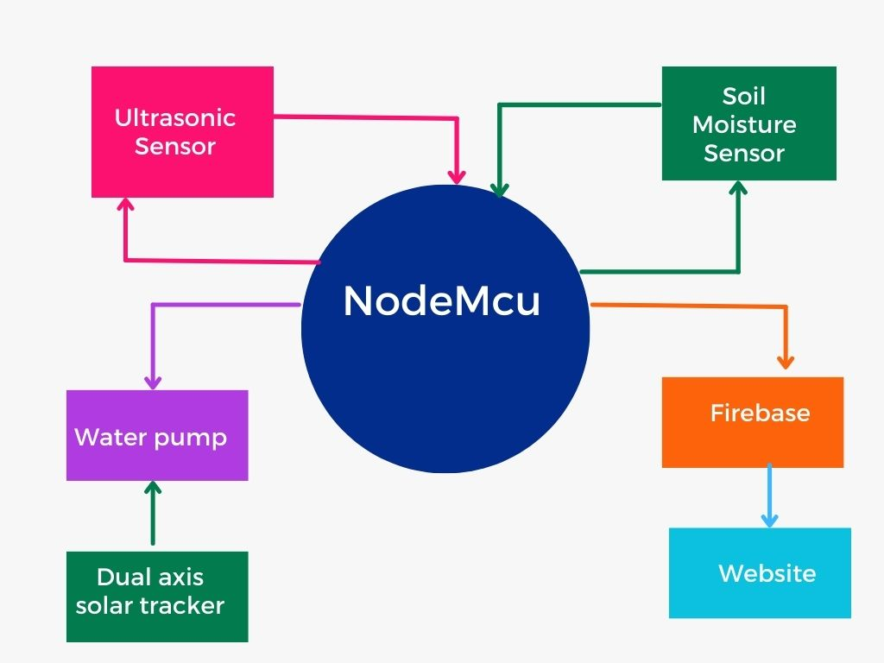

Fig3: Block diagram of IoT-based irrigation system

*Soil moisture sensor (FC-28)*

It measures the soil conditions/moisture level under various conditions. It requires an input voltage of 5V to activate. The output voltage range is 0-4.2V under different moisture conditions.

*Ultrasonic sensor (HCSR-04)*

In our system, it measures the tank level where the water is stored for irrigation purposes. It has a maximum range of 400cm and a minimum range of 2cm also the operating voltage is near about 5V.

*DC submerged water pump*

Used for supplying water to plants.

*Nodemcu (ESP8266)*

Based on ESP8266 it is a wi-fi enabled microcontroller that enables the system to interact with Firebase and store real-time data and results.

*Power Supply*

Used to provide power to hardware setup from 5-12V.

*Relay*

Utilized for proper functioning of the DC pump.

*Google Firebase*

Stores the data and results fetched from the microcontroller and different sensors on a real-time basis, and provides different alerts accordingly.

*Website*

A simple web interface based on HTML, CSS, and JS that communicates with the Firebase and enables users to see all the data and results.

In our design, all sensors are connected to the microcontroller. A DC power supply is used to power them. The soil moisture sensors sense the moisture level of the soil under different conditions and compare with the predefined threshold value and depending on the value the DC pump is triggered to water the plants. The DC pump is powered using the battery and this battery gets energy from the dual-axis solar tracker. We are using renewable sources of energy in our system to power the pump and ignite the water supply. The soil moisture value and the watering status are measured in real-time and sent to Firebase after which the user can access it globally and keep track of crop irrigation. Next, the ultrasonic sensor comes into the picture it is kept over the main water tank from which the dc pump supplies water to the crops. This sensor keeps track of the amount of water present in the tank, if the tank falls on water, then the user is alerted via Firebase.

The watering status is measured based on the feedback of the DC pump, the pump is connected to the relay, if the relay is in the high state that means the pump is on and watering is being done, if the relay is in the low state then the pump is off and watering is stopped or not being done at that time. The ESP8266-based NodeMcu microcontroller facilitates wi-fi connectivity to our system enabling the sensors and the microcontroller to communicate with the Google Firebase and store data in real-time. The NodeMcu develops wireless communication between the hardware components and the Firebase. The website helps users to monitor the entire automated process globally. Users can keep track of soil moisture conditions, water tank level, watering status and all other results from any part of the world.

**References**

1. Experimental performance of smart IoT-enabled drip irrigation system using and controlled through web-based applications Ravi Kant Jain a,b,c,d,* a Design Mangement and System Engineering (DSME) Group, CSIR-CMERI, Durgapur, India b Engineering Support Division (ESD-Insitute), CSIR-CMERI, Durgapur, India c AcSIR, India d CSIR-Central Mechanical Engineering Research Institute (CMERI), Durgapur 713209, India
2. Mohanraj I, Ashokumar K, Naren J. "Field Monitoring and Automation using IoT in Agriculture Domain." In: Proceedings of the 6th International Conference On Advances In Computing & Communications (ICACC 2016), September 6-8, 2016, Cochin, India. B.Tech Computer Science and Engineering, School of Computing, SASTRA University, Thanjavur - 613401, India.
3. Foughali, K., Fathalah, K., & Ali, F. (2017). Monitoring system using web of things in precision agriculture. In Proceedings of the 12th International Conference on Future Networks and Communications (FNC 2017). [Conference Presentation].
4. Rad, Ciprian-Radu, Olimpiu Hancu, Ioana-Alexandra Takacsa, and Gheorghe Olteanu. "Smart Monitoring of Potato Crop: A Cyber-Physical System Architecture Model in the Field of Precision Agriculture." Proceedings of the International Conference "Agriculture for Life, Life for Agriculture" (ST26733), [Conference Location], [Conference Year].
5. Ismail, F. B., Rahmat, M. A. A., Kazem, H. A., Al-Obaidi, A. S. M., & Ridwan, M. S. (Year). Maximizing energy via solar-powered smart irrigation: An approach utilizing a single-axis solar tracking mechanism. *Journal/Conference Name*, Volume(Issue), Page range.
6. Oksanen, T., Linkolehto, R., & Seilonen, I. (2016). Adapting an industrial automation protocol to remote monitoring of mobile agricultural machinery: a combine harvester with IoT. In 5th IFAC Conference on Sensing, Control and Automation for Agriculture (pp. 127). Seattle, Washington, USA: IFAC.
7. Rumy, S. M. Shahidur Harun, Tanvin, Tanjina, Hossain, Md. Ishan Arefin, & Jahan, Forji. (Year of Publication). "An IoT based System with Edge Intelligence for Rice Leaf Disease Detection using Machine Learning." *Journal/Conference Name,* Volume(Issue), Page Range.
8. Karthika, A., Jayanthi, S., & Deivamani, G. (2019). Dual Axis Solar Tracking System Using Arduino. *International Research Journal of Engineering and Technology (IRJET),* 6(03), 1033.
9. Sarojini, L., Jenifar, J., Mythili, M., Sushmitha, J., & Venkatesan, S. (2016-17). "Real-time Implementation of Drip Irrigation Using PLC." *Department of EEE, Periyar Maniammai University, Tamilnadu, India.
10. Bagwan, N., Kushire, P., Deshpande, M., Singh, P., & Gupta, S. (2017). Efficient Water Saving Technique for Green Farming using IoT. Department of Computer Engineering, Savitribai Phule Pune University, Maharashtra, India.
11. Wakchaure, M. A., Kale, N. L., Gawade, P. G., Gangule, L. V., & Chate, L. D. (2018). Automation in Agriculture to Optimize Utilization of Water and Crop Monitoring using IoT. *International Journal of Computer Applications*, 180(50).
12. Phasinam, K., Kassanuk, T., Shinde, P. P., Thakar, C. M., Sharma, D. K., Mohiddin, Md. K., & Rahmani, A. W. (2022). Application of IoT and Cloud Computing in Automation of Agriculture Irrigation. Faculty of Food and Agricultural Technology, Pibulsongkram Rajabhat University, Phitsanulok, Thailand; School of Agriculture & Food Engineering, Faculty of Food and Agricultural Technology, Pibulsongkram Rajabhat University, Phitsanulok, Thailand; Department of MCA, Government College of Engineering, Karad, India; Department of Mechanical Engineering, Government College of Engineering, Karad, Maharashtra, India; Department of Mathematics, Jaypee University of Engineering and Technology, Guna, MP, India; Bhilai Institute of Technology, Raipur, Chhattisgarh, India; Isteqlal Institute of Higher Education, Kabul, Afghanistan. Correspondence: Abdul Wahab Rahmani; [ab.wahab.professor@isteqlal.edu.af](mailto:ab.wahab.professor@isteqlal.edu.af).
13. Ashok, Gajjala, and Rajasekar Gogada. "Smart Drip Irrigation System using Raspberry Pi and Arduino." *Journal of Electrical and Computer Engineering*, vol. 2024, Article ID 1234567, 2024. doi:10.1155/2024/1234567.
14. Hamami, Loubna, and Nassereddine Bouchaib. "Integration of Irrigation System with Wireless Sensor Networks: Prototype and Conception of Intelligent Irrigation System." Proceedings of the World Congress on Engineering and Computer Science 2018 Vol I, WCECS 2018, October 23-25, 2018, San Francisco, USA.
15. Rahmat, Muhammad Bakhit Izzuddin, and Mohd Jais Che Soh. "IoT Based Smart Agriculture Monitoring and Irrigation System." Evolution in Electrical and Electronic Engineering Vol. 5, No. 1 (2024): 581-586
16. Joshi, A. Y., Kadam, S. V., Jain, R. K., & Kulkarni, H. B. (2024). IoT Based Smart Irrigation System. *School of Mechatronics, Symbiosis Skills and Professional University, Pune, India*.
17. Obaideen, K., Yousef, B. A. A., AlMallahi, M. N., Tan, Y. C., Mahmoud, M., Jaber, H., & Ramadan, M. (2022). An overview of smart irrigation systems using IoT. [Journal Name], [Volume Number](Issue Number), Page Range.
18. Bedekar, Sumeet S., Monoj A. Mechkul, and Sonali R. Deshpande. "IoT based Automated Irrigation System." International Journal for Scientific Research & Development 3.04 (2015): 1015.
19. Mohamed Junaid, K. A., Sukhi, Y., & Anita, S. (Year not provided). Low-Cost Smart Irrigation for Agricultural Land Using IoT. Department of Electronics and Communication Engineering, R.M.K. Engineering College, RSM Nagar, Gummidipoondi, Taluk, Kavaraipettai, Chennai, Tamil Nadu 601206, India.
20. R, D., L, K., & S, B. (2021). A Novel Technique using IoT Based Automated Irrigation System for Smart Farming. *Journal of Agricultural Informatics*, 12(3), 45-58.
21. Kumar, A., Kumar, A., & Sharma, P. K. (2017). Smart Irrigation System using IoT: SIS. Department of ECE, BKBIET, Pilani, Rajasthan, India.
22. Swaraj C M, & K M Sowmyashree. "IoT based Smart Agriculture Monitoring and Irrigation System." PES College of Engineering, Mandya, Karnataka, India.
23. Kumari, Dr. Madhu, and Anant Kumar Sah. "IoT Enabled Smart Irrigation System, Monitoring and Water Harvesting in Different Soils." International Journal of Engineering Research & Technology (IJERT), vol. 10, no. 03, March 2021, ISSN: 2278-0181, http://www.ijert.org, Published by www.ijert.org.
24. Sharma, Navneet, Abdul Hakkim V.M., and Atul Kumar Singh. "Development and field evaluation of a low-cost automated drip irrigation system." *International Journal of Engineering Research & Technology* (IJERT), vol. 10, no. 3, March 2021, pp. 1-7.
25. Pimpalkar, P., Pedsangi, N., & Phapale, P. (2021). Smart Irrigation System. *International Journal of Advanced Research in Computer and Communication Engineering*, 10(11), 135. DOI: 10.17148/IJARCCE.2021.101125.
26. Mane, S. S., Mane, M. S., Kadam, U. S., & Patil, S. T. (2019). Design and Development of Cost Effective Real Time Soil Moisture based Automatic Irrigation System with GSM. *International Research Journal of Engineering and Technology (IRJET)*, 06(09), 1744. Retrieved from <http://www.irjet.net>.
27. Apat, S. K., Mishra, J., Raju, K. S., & Padhy, N. (Year). "IoT-Assisted Crop Monitoring Using Machine Learning Algorithms for Smart Farming."
28. Rehman, A., Liu, J., Keqiu, L., Mateen, A., & Yasin, M. Q. (2020). Machine Learning Prediction Analysis using IoT for Smart Farming. *International Journal of Emerging Trends in Engineering Research*. Retrieved from <http://www.warse.org/IJETER/static/pdf/file/ijeter250892020.pdf>
29. Sahu, P. K., Malla, S., Khuntia, M., Rath, S., & Nayak, M. (2024). Smart Crop Prediction Using Statistical Techniques of Machine Learning Through IoT. *Journal of Theoretical and Applied Information Technology, 102*(7), 3131. Retrieved from <http://www.jatit.org>